**Day 13 docs**

**Task -1:**

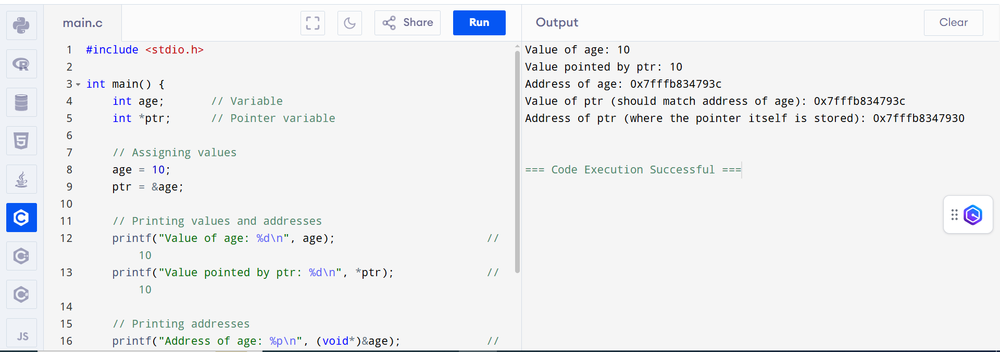

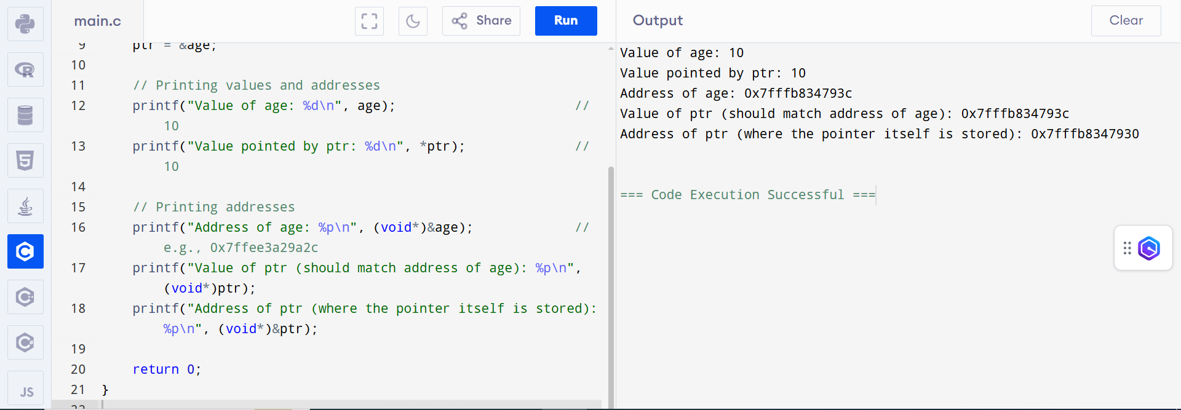

**Task -2**

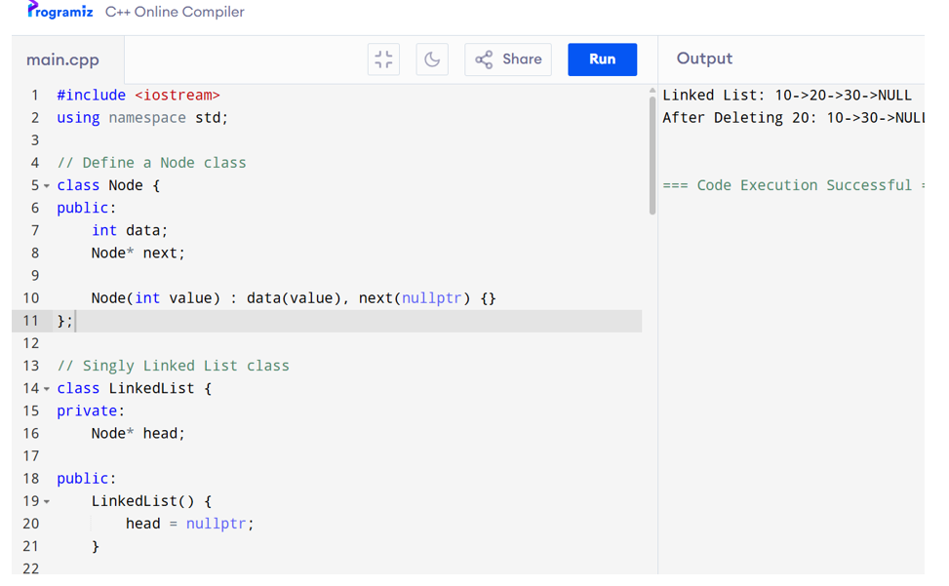

**Task -3:**

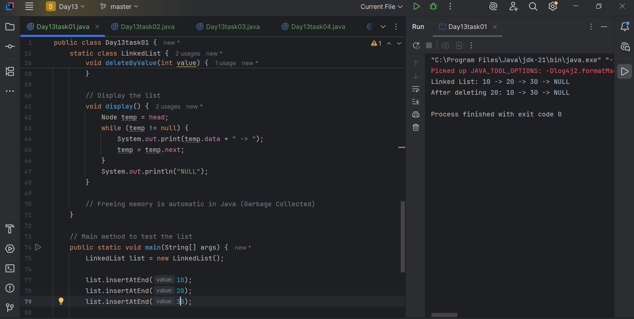

**Task – 4:**

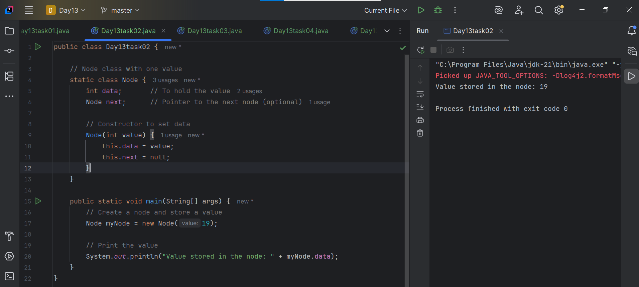

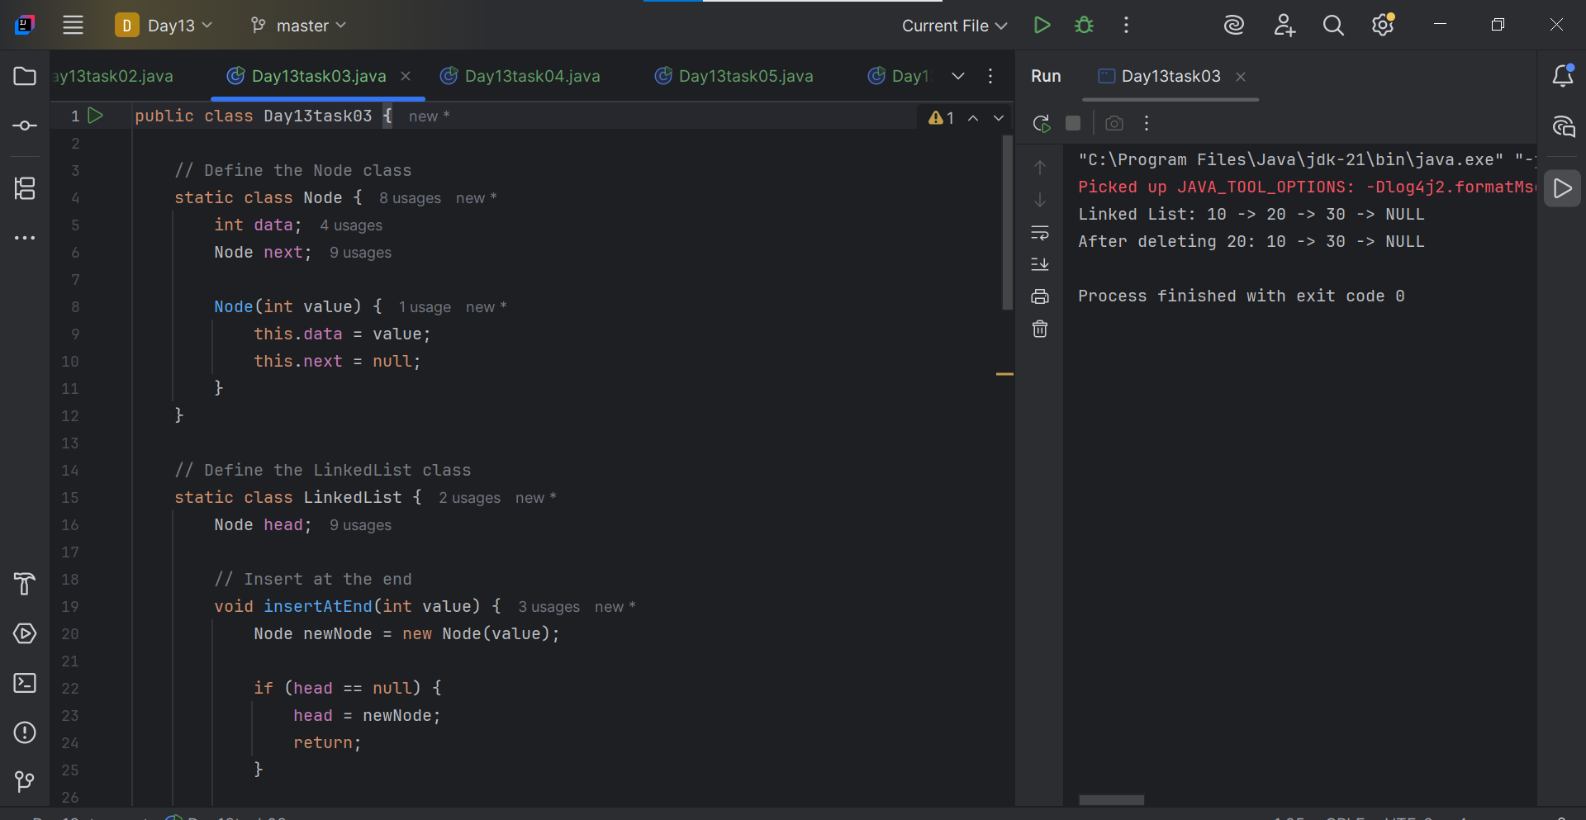

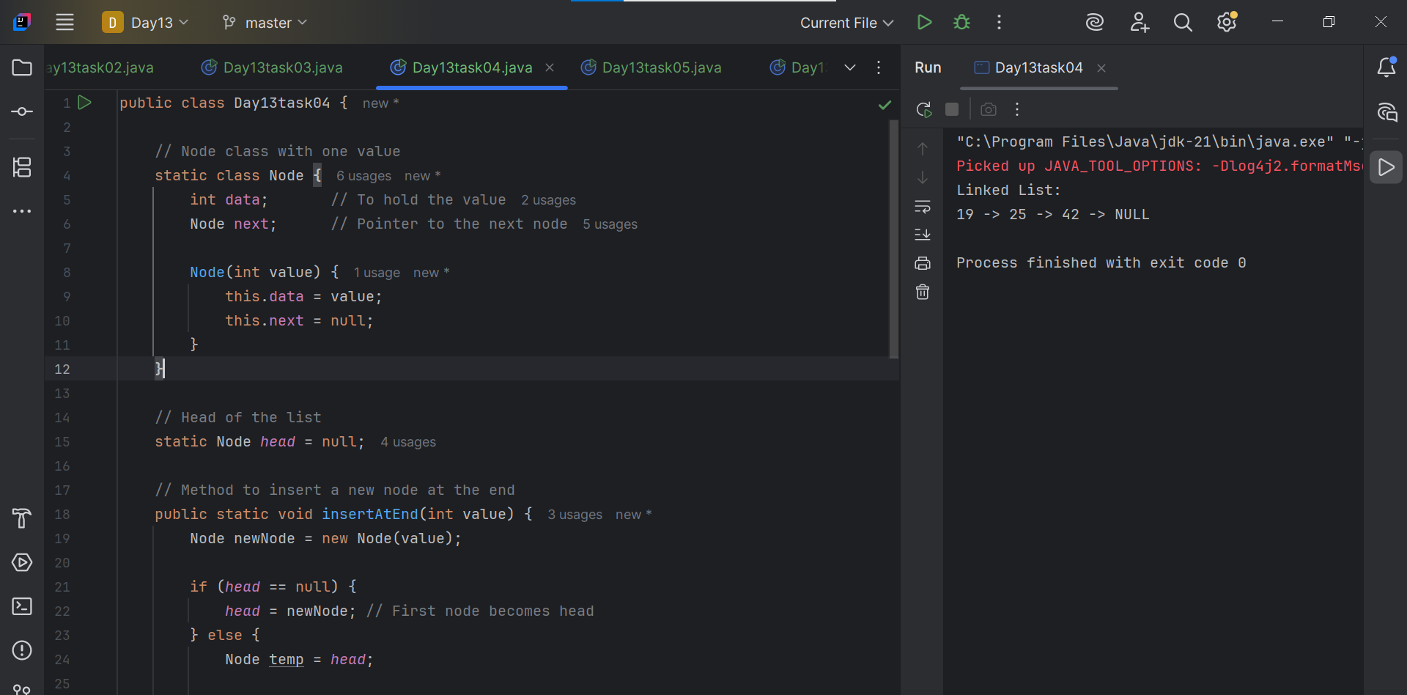

**Task - 5:**

### **Linked List Methods:**

|  |  |  |
| --- | --- | --- |
| Category | Method | Description |
| Creation | createNode(value) | Creates a new node |
|  | insertAtBeginning(value) | Inserts node at the beginning |
|  | insertAtEnd(value) | Inserts node at the end |
|  | insertAtIndex(index, value) | Inserts node at a specific position |
| Deletion | deleteByValue(value) | Deletes the first node with matching value |
|  | deleteAtBeginning() | Deletes the first node |
|  | deleteAtEnd() | Deletes the last node |
|  | deleteAtIndex(index) | Deletes node at a specific position |
| Access / Retrieval | getElementAt(index) | Returns value at a specific index |
|  | search(value) | Searches for a value and returns index/boolean |
| Traversal / Display | display() or printList() | Prints all nodes in the list |
| Size | getSize() | Returns the number of nodes in the list |
| Check Conditions | isEmpty() | Returns true if the list is empty |
|  | contains(value) | Returns true if value exists in the list |
| Clear | clear() | Deletes all nodes and resets the list |

**Task : 6**

**Here’s a list of common methods used in a Linked List (especially for a singly linked list) in most programming languages like Java, C, or Python.**

**Task -7:**

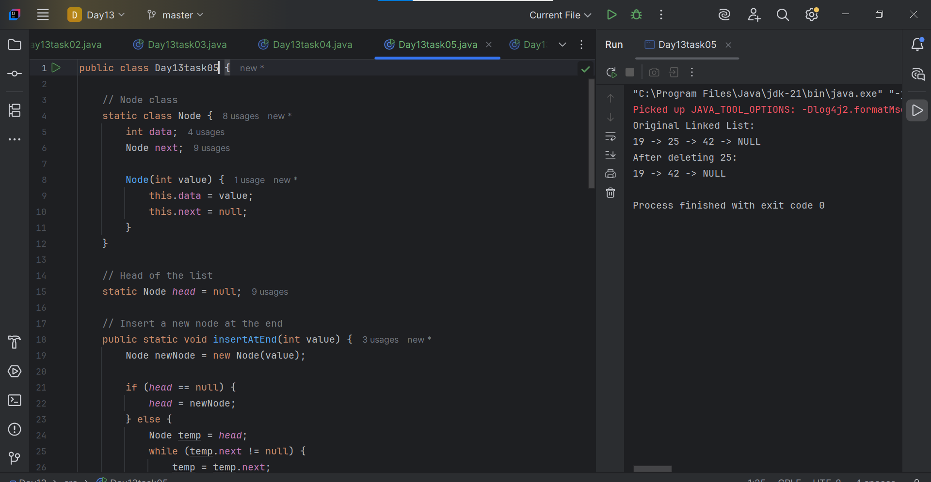

**Task -8:**

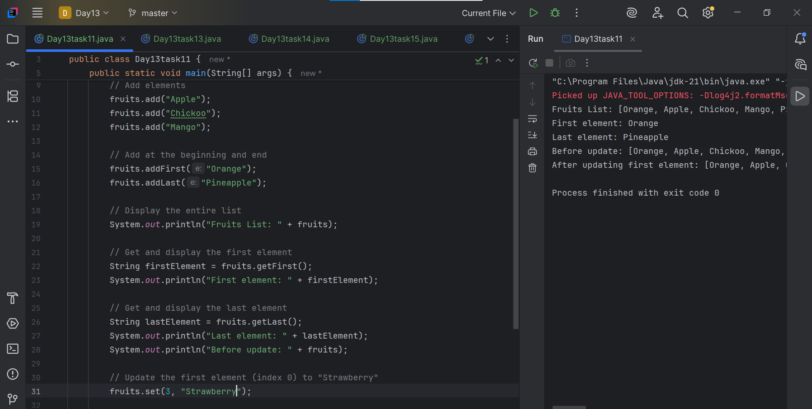

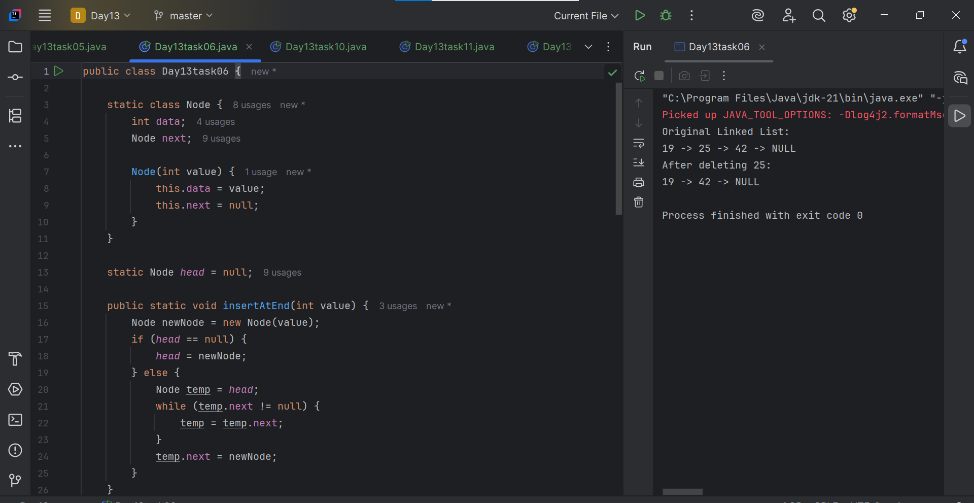

**Task 9:**

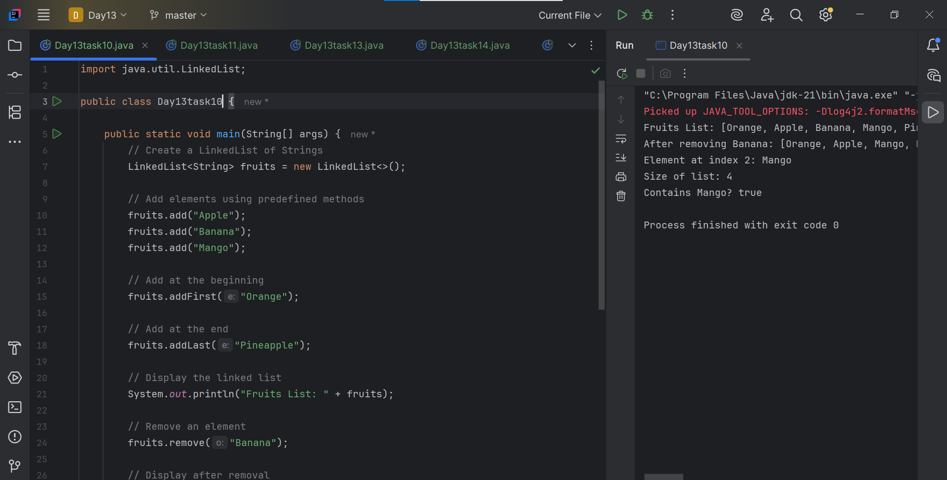

**Task – 10:**

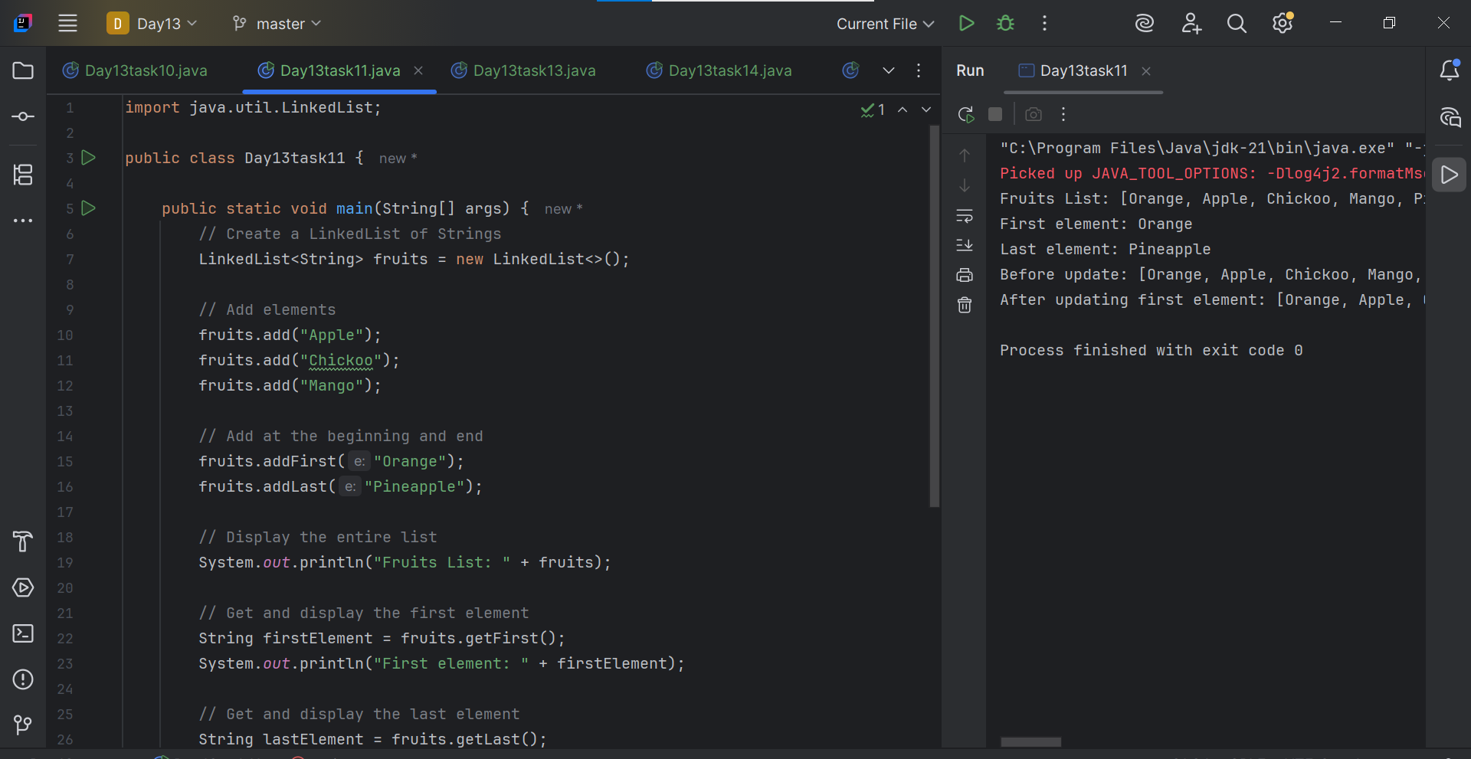

**Task – 11:**

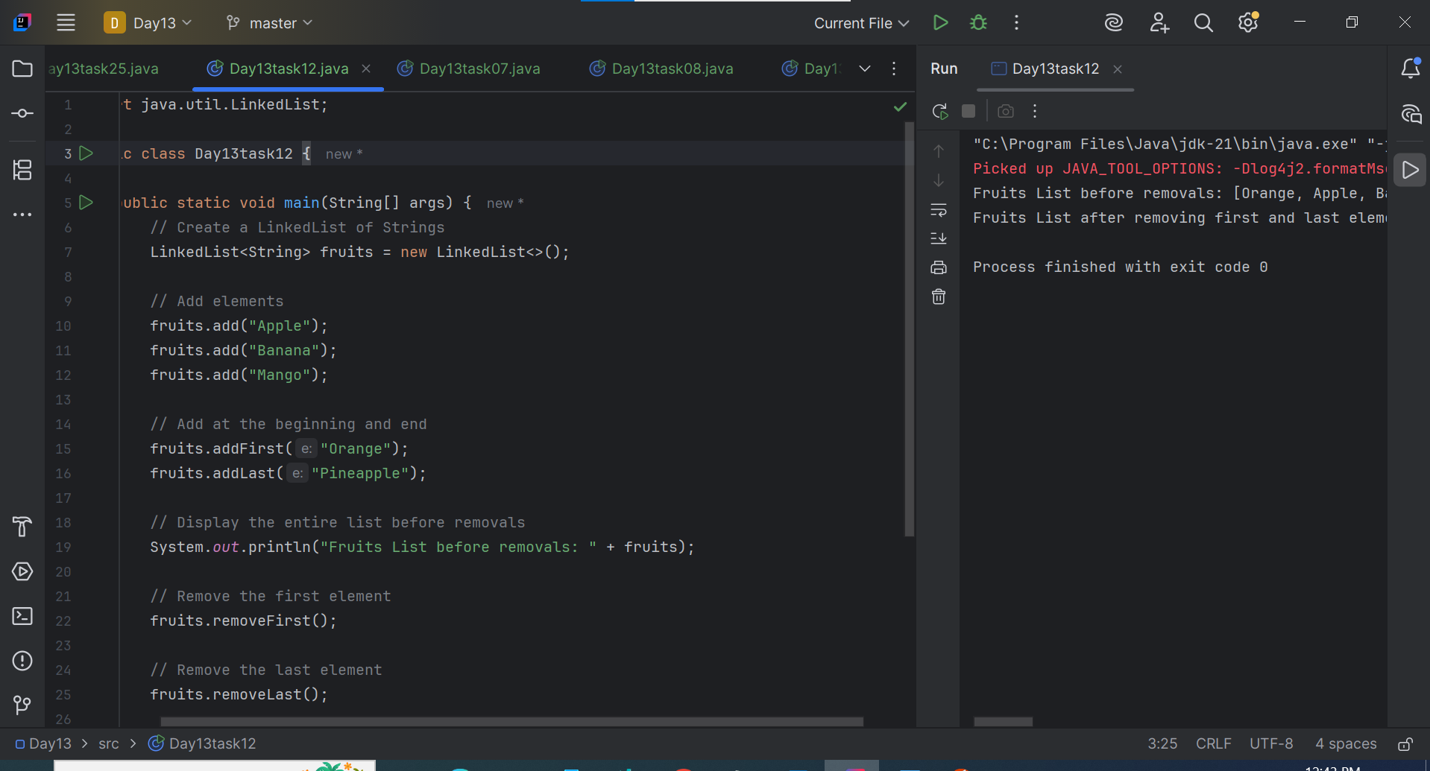

**Task – 12:**

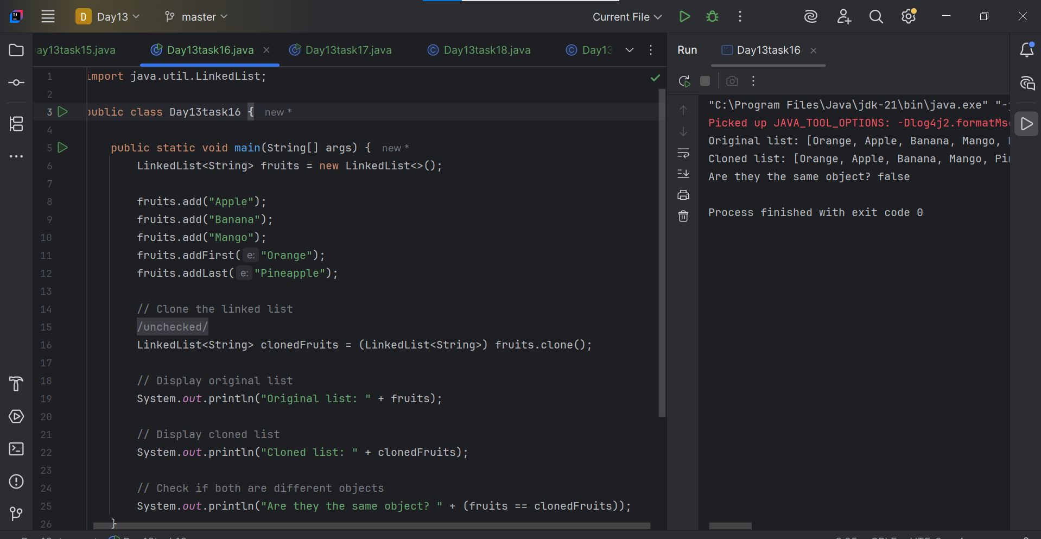

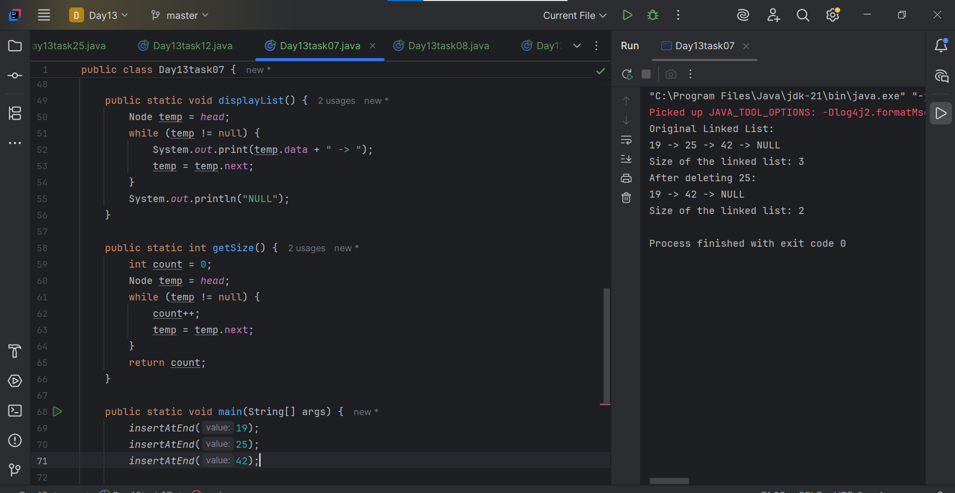

**Task – 13:**

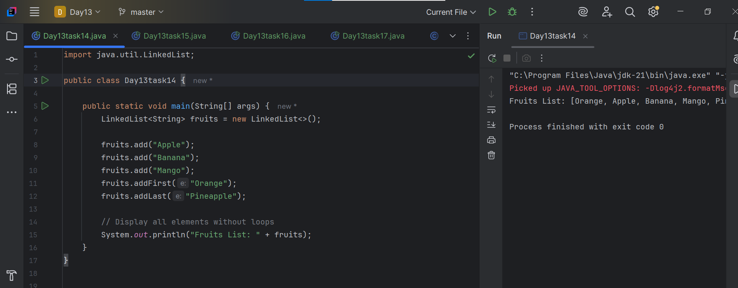

**Task – 15:**

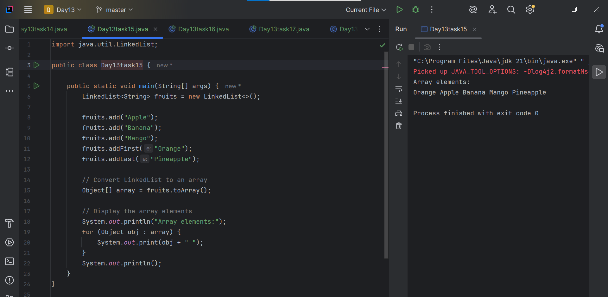

**Task – 16:**

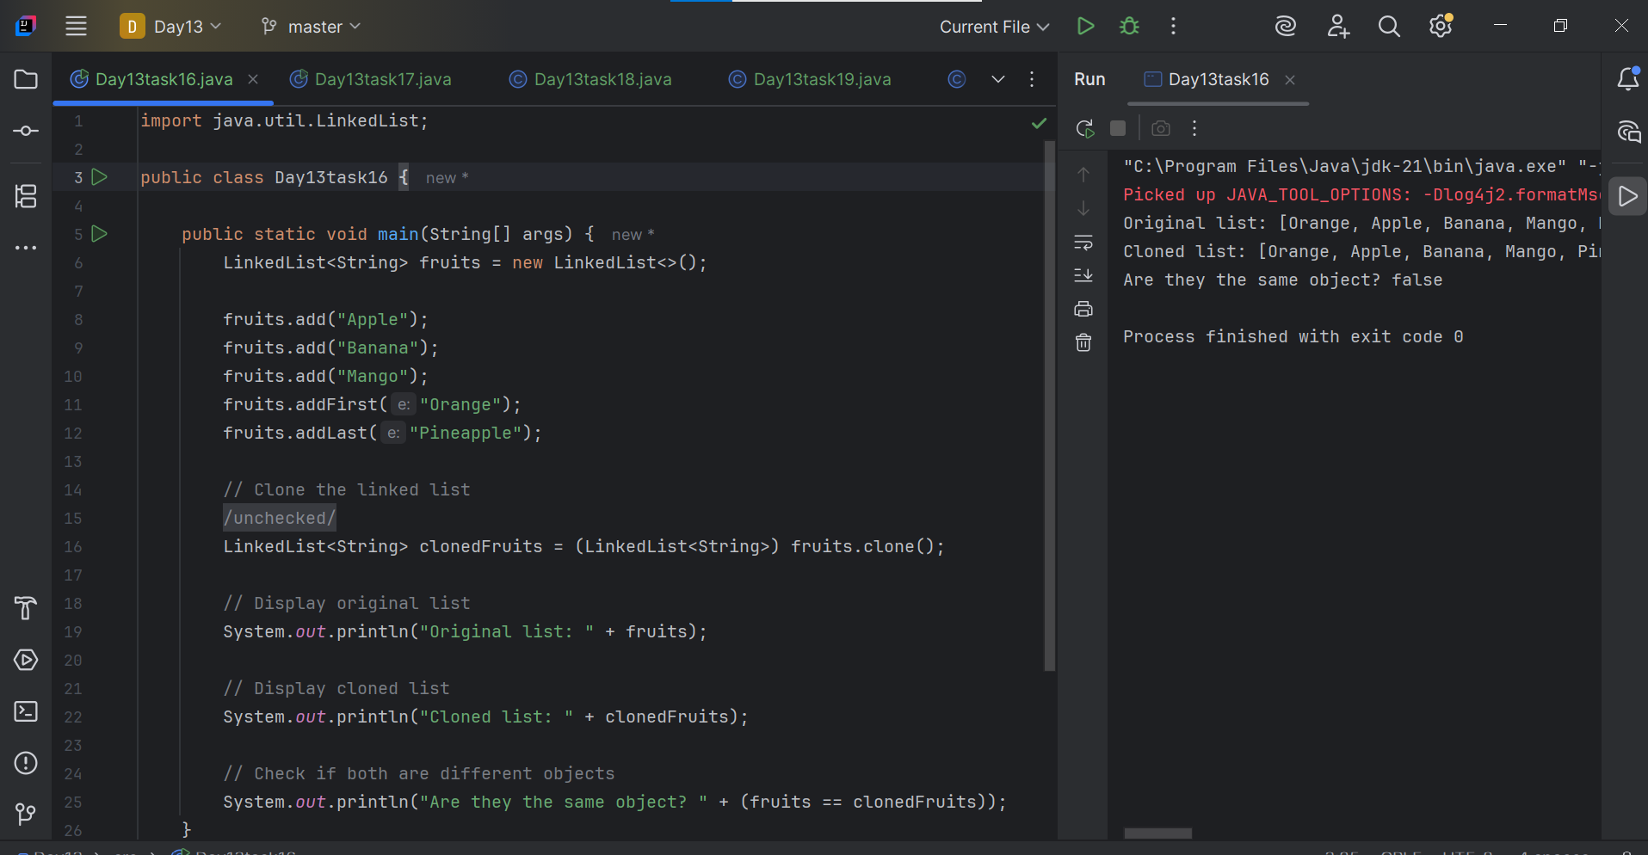

**Task – 17:**

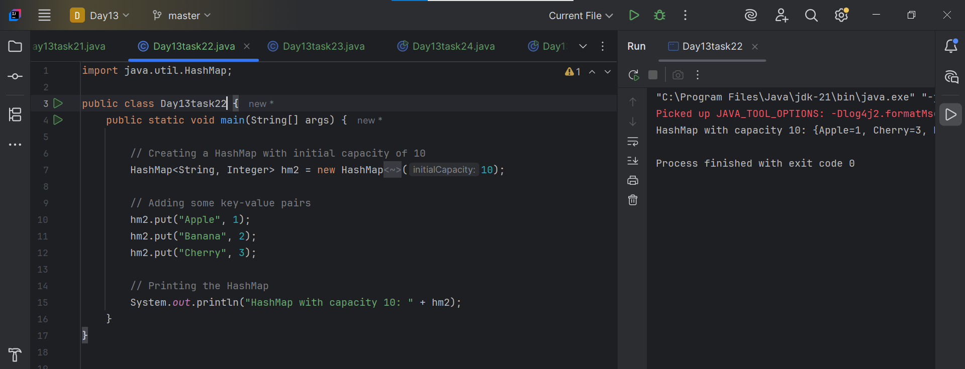

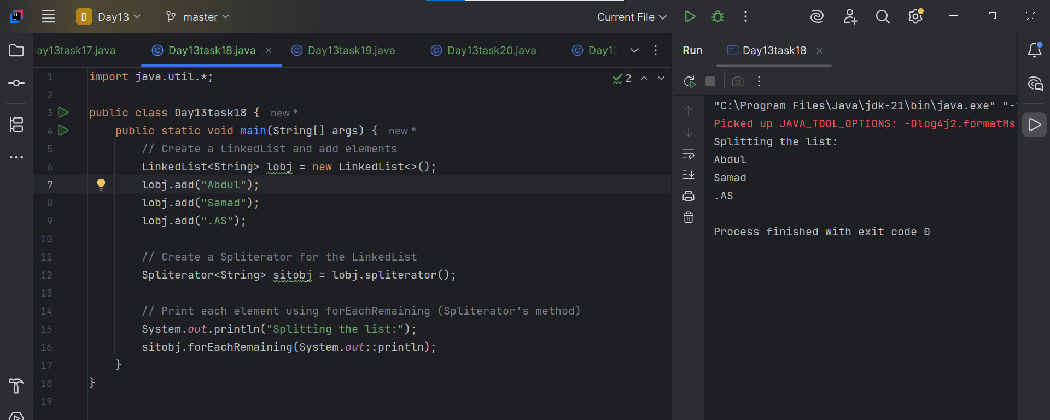

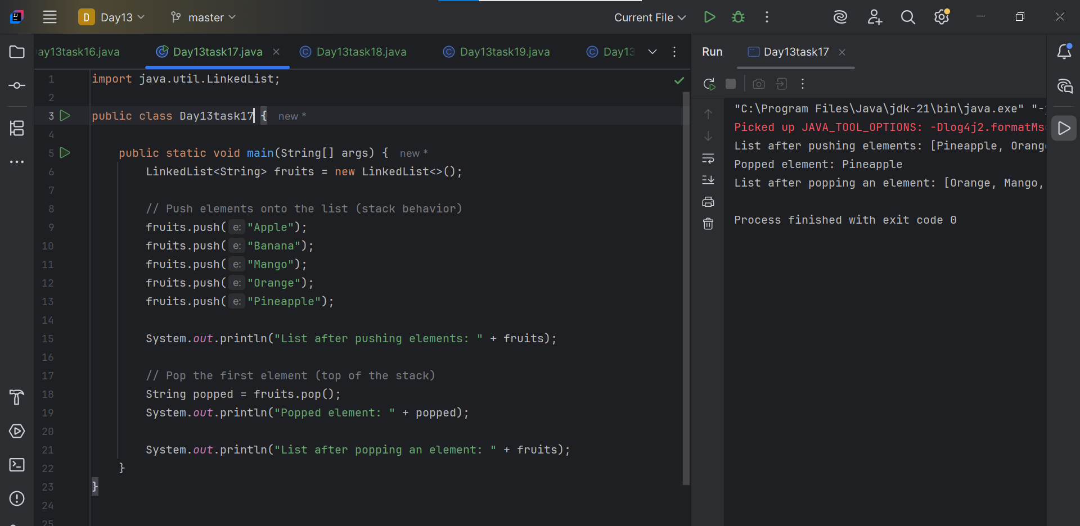

**Task – 18:**

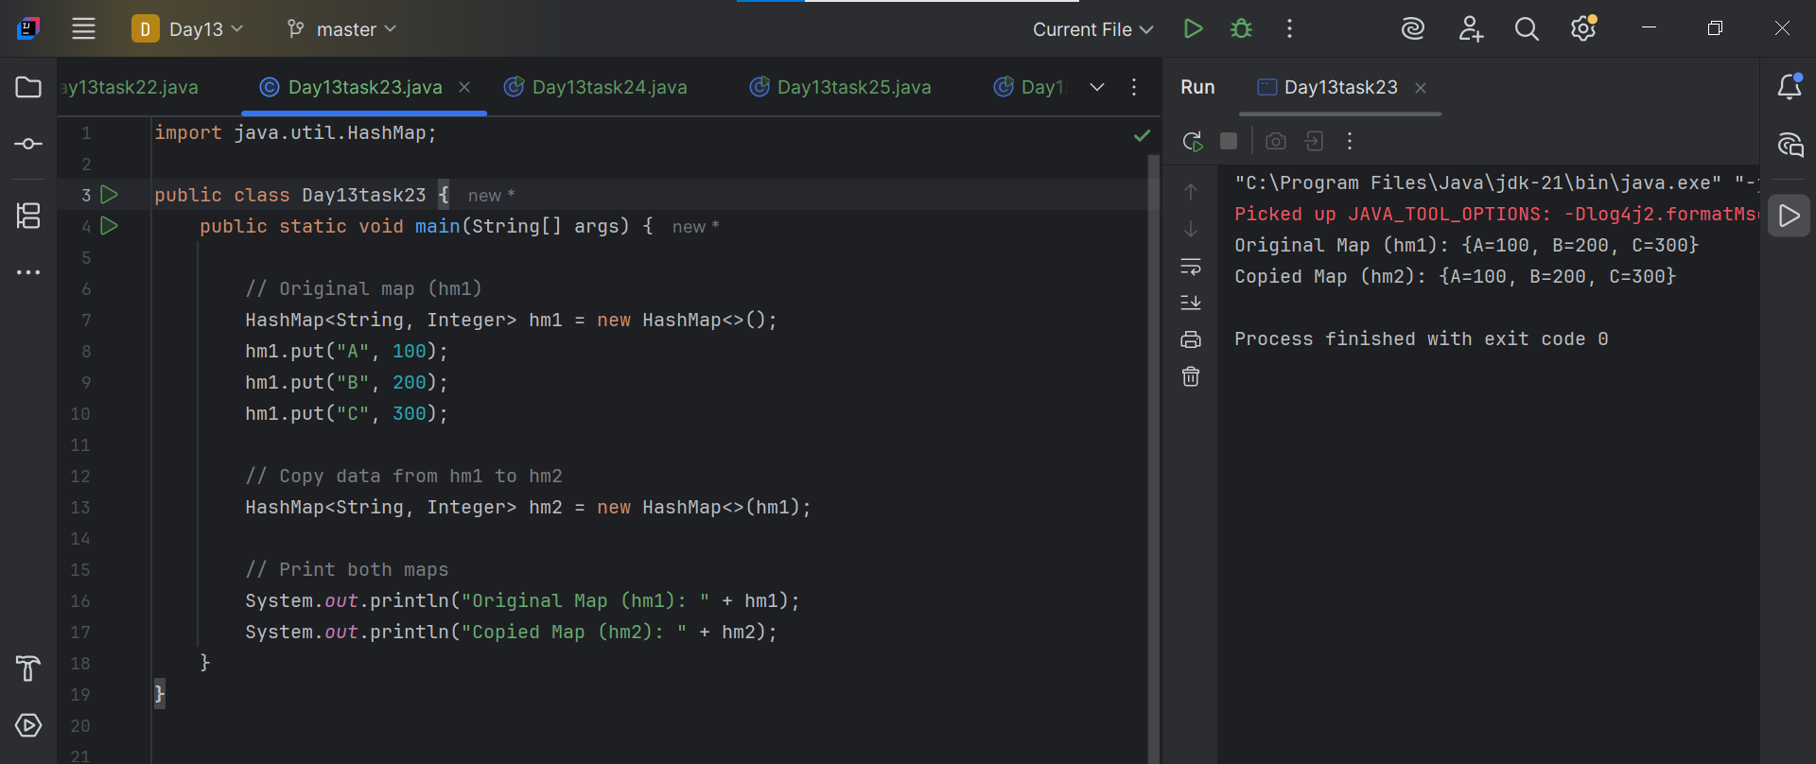

**Task – 19:**

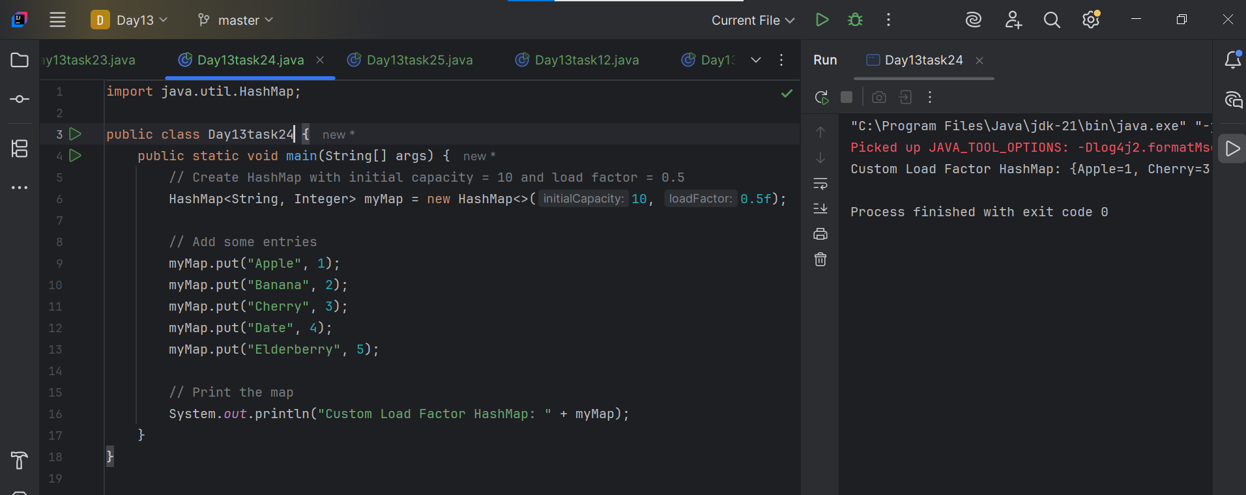

**Task – 20:**

